Rebranding, Trust, and Technology: Examining Zuckerberg’s Image Overhaul

Mark Zuckerberg, the CEO of Facebook (now Meta), has undergone a deliberate transformation to reshape public perception of himself and his company. In the face of growing scrutiny over Facebook’s impact on society, Zuckerberg has aimed to project a more transparent and empathetic image. This rebranding is particularly evident in his approach during the 2018 congressional hearings, where he openly acknowledged Facebook’s failings regarding data privacy and misinformation. By apologizing publicly and stating, “We didn’t do enough to prevent these tools from being used for harm,” he aimed to demonstrate accountability. This marked a shift from the often distant and tech-driven persona to one that acknowledged the human and societal implications of Facebook’s operations.

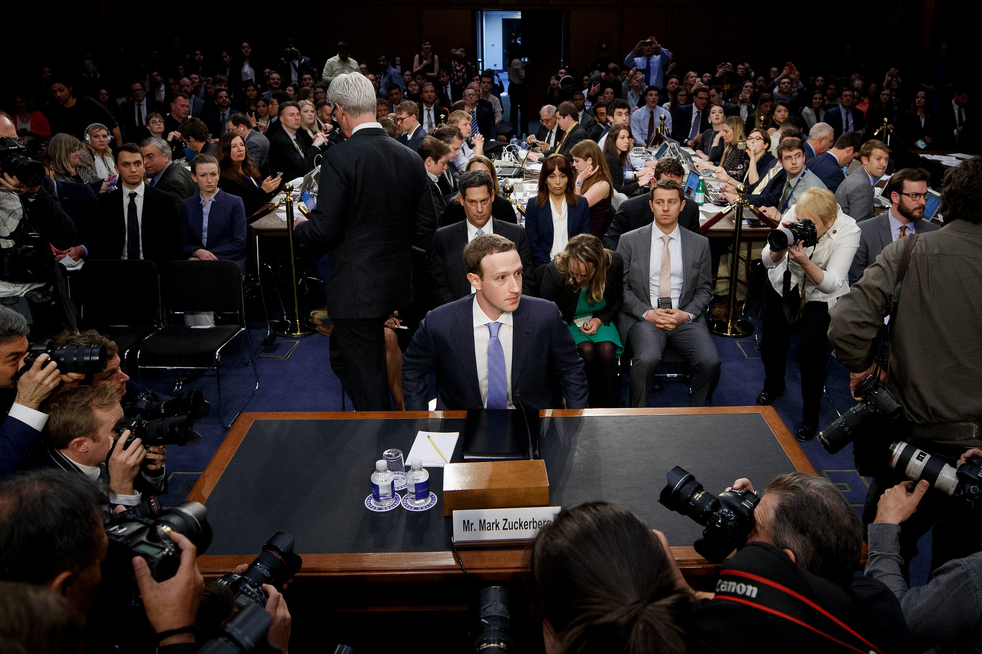
Facebook chief Mark Zuckerberg testified in the 2018 congressional hearing, emphasizing his effort to engage with public concerns.

Another key step in this rebranding journey was Zuckerberg’s 2017 cross-country tour to engage with diverse communities and perspectives. Visiting small towns and hosting discussions, he attempted to present himself as a relatable leader committed to understanding the lives of ordinary people. The tour, documented in videos and posts, was seen as an effort to humanize his image and counter the perception of him as a detached billionaire. Additionally, Zuckerberg’s philanthropic initiatives, such as the pledge to donate 99% of his Facebook shares to societal causes, further cemented his commitment to addressing global challenges. His philanthropic focus on personalized education and health highlighted his willingness to address deeper societal issues beyond the scope of Meta’s business operations.
Picture to Add: A map or collage depicting Zuckerberg’s cross-country tour stops, showing his effort to connect with people from different backgrounds.



Mark Zuckerberg surfs, sips beer in a tux for viral July 4

Despite these efforts, Zuckerberg and Meta continue to face criticism for controversies that have significantly tarnished their reputation. The Cambridge Analytica scandal, where data from 87 million users was misused, remains one of the most damaging incidents in Meta’s history. Coupled with allegations of monopolistic practices, the spread of misinformation, and mental health concerns related to its platforms, these issues have raised questions about the company’s priorities. Zuckerberg’s leadership style, often described as “move fast and break things,” has also come under fire for prioritizing growth over user safety and security. While his apologies and attempts at reform have been noted, critics argue that meaningful changes—such as simplifying privacy settings and fostering transparency—are still lacking.
(Picture to Add: An infographic or timeline of major Meta controversies, including the Cambridge Analytica scandal and other public incidents.)
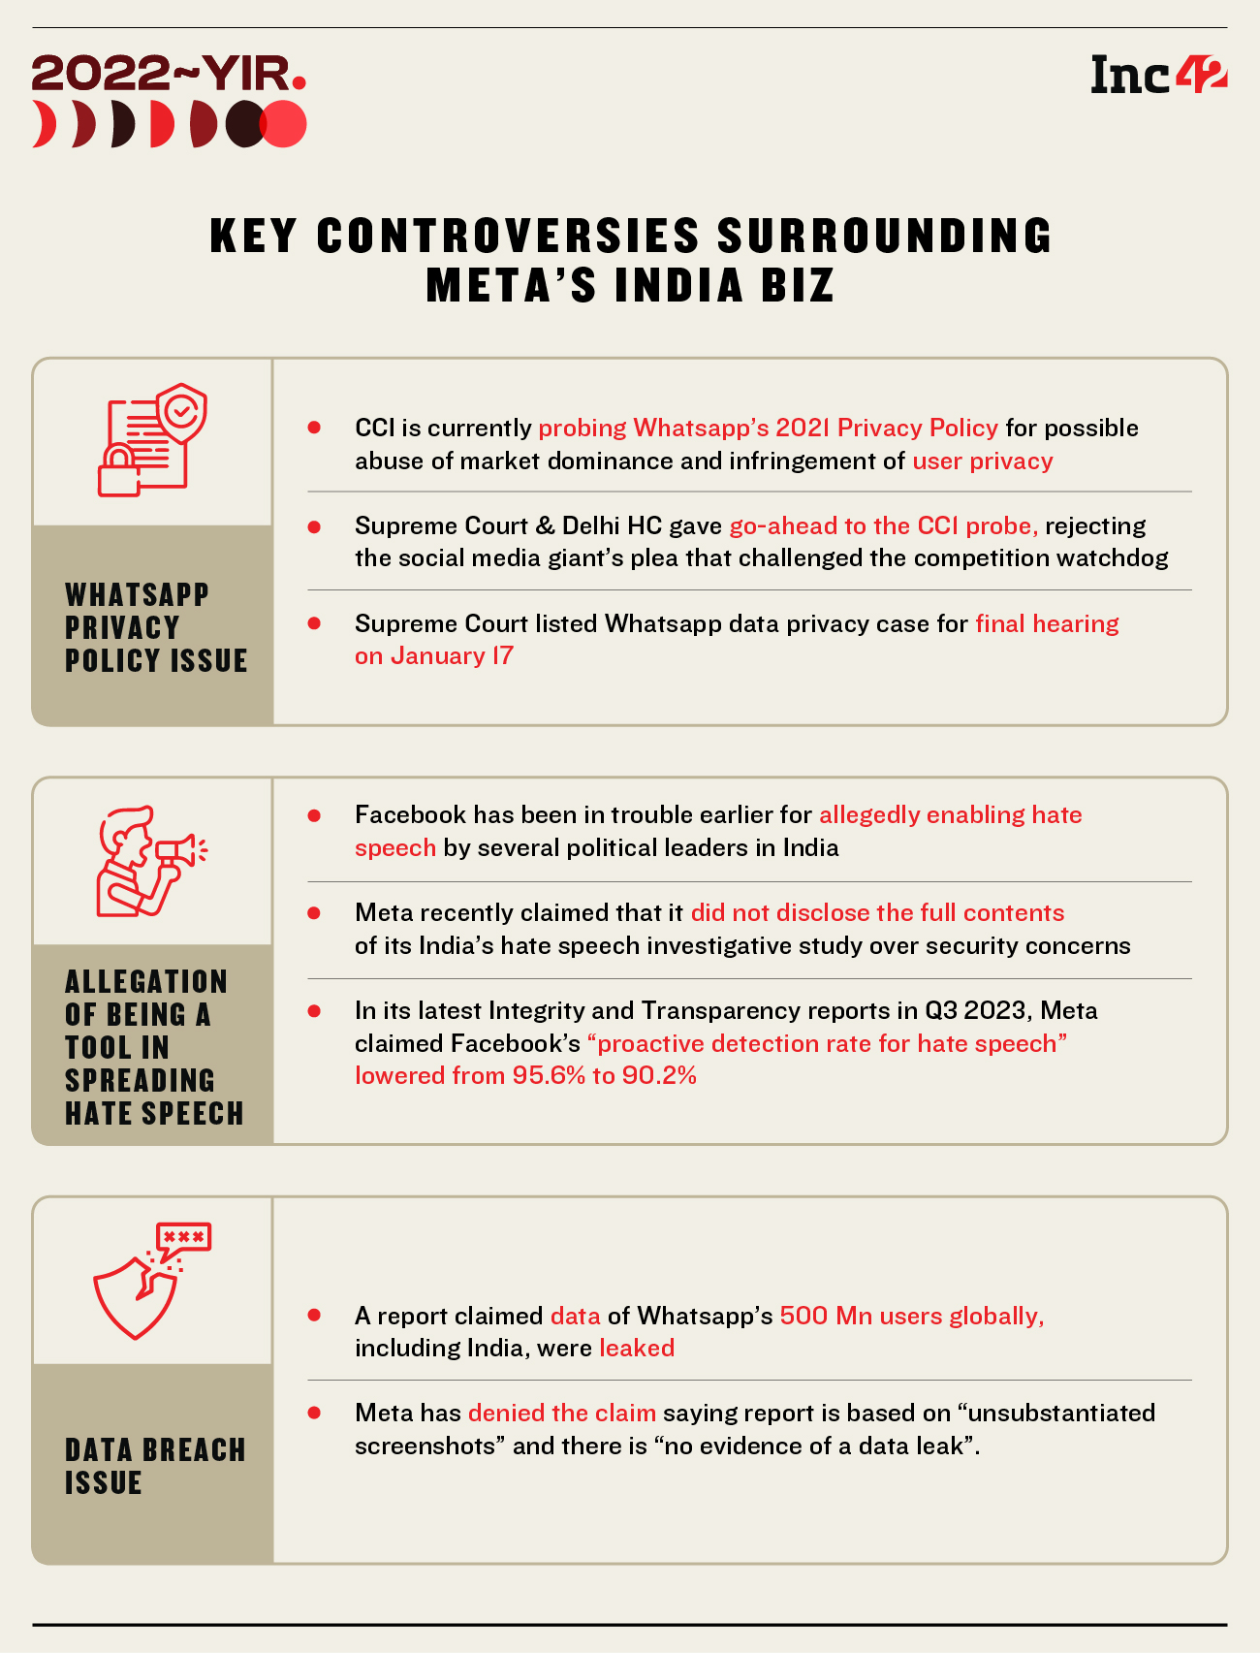

2022 & The Many Controversies That Shook Meta's India Dynamics

In recent years, Zuckerberg has pivoted Meta’s focus to the metaverse, rebranding the company to align with his vision of a virtual future. This ambitious shift involves a $10 billion investment in creating immersive virtual and augmented reality experiences. While the metaverse promises groundbreaking applications in education, entertainment, and social interaction, it also raises concerns about data privacy and potential monopolization of virtual spaces. Zuckerberg’s portrayal of this move as an opportunity to build a new digital frontier is part of his broader effort to position Meta as a forward-thinking leader in technology. However, challenges persist, as other tech giants like Microsoft and Apple also compete in this space.
Picture to Add: A futuristic illustration of the metaverse, showcasing virtual reality headsets, digital avatars, and interconnected virtual spaces.



Finally, Zuckerberg’s rebranding efforts illustrate the broader challenges leaders face when attempting to reshape public perception. Psychological factors such as confirmation bias influence how audiences interpret his actions, with many skeptics dismissing his transparency and philanthropic endeavors as damage control. However, his case demonstrates how CEOs can shape their companies’ narratives, for better or worse, by aligning their personal branding with their organization’s evolving goals. For Zuckerberg, the battle for trust remains ongoing, as Meta navigates the balance between innovation, public accountability, and ethical leadership.
Picture to Add: A graph showing public trust levels in Facebook/Meta over time, reflecting the impact of controversies and rebranding efforts.



